**Salary Check release process**

**Main Key Process:**

1. Create a list containing department code

* listOfDepartment = dt_input.AsEnumerable.Select(Function(x) x("Department").ToString).ToList()

1. For each department in the list:
2. Create a folder
3. Add item to department-wise expense dictionary
4. Filter Employee Data table based on the department
5. Save the Excel file to the department folder
6. For each Folder in the Directory:
7. Read the Excel file
8. Get Ascii Value for Adding Final Amount Cell

* finalAmountCell = Chr(dt_employee.ColumnCount+65)

1. For each row in the data table:
2. If Casual leave > 1 🡪Final Amount = Deducted Amount

🡪Highlight row with yellow color

1. Else: 🡪Final Amount = Gross Salary
2. Write Final Amount in sheet
3. Add the Final Amount to the Department wise dictionary
4. For Each Folder in the Directory:
5. Read the Excel file
6. Generate Cheque & Save it to the folder

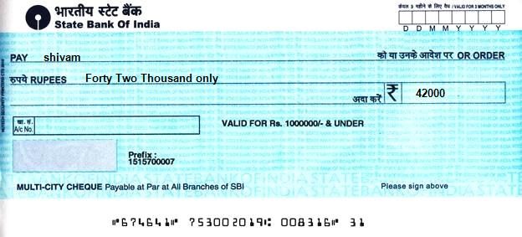

1. Generate an Analytical Report

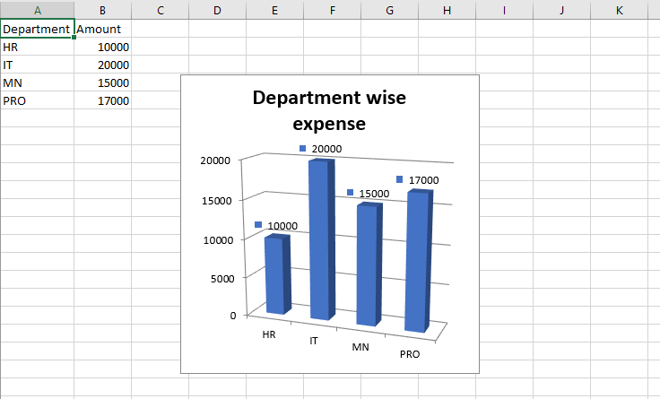

1. Upload the Report to the folder
2. Send Mail To the respective team manager
3. Update the department-wise expense Excel from the dictionary

**The workflow I chose:**

I decided to go with a sequential workflow because the process seems to be sequential and there are no more system-related activities that are prone to cause system exceptions that need to be handled. Also, we have data in the form of Excel so we don’t require to scrap the data and add it to a queue i.e. dispatcher. So, there is no need to use REFramework.

**Flow Diagram (Monthly Process):**

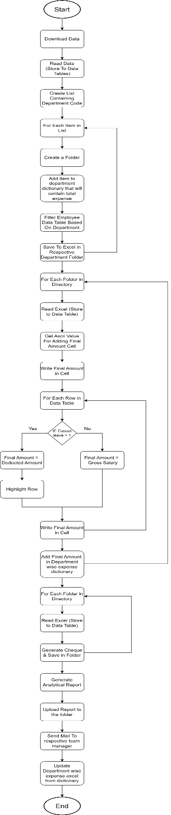

**Flow Diagram (Yearly Process):**

